**Yom Kippur**

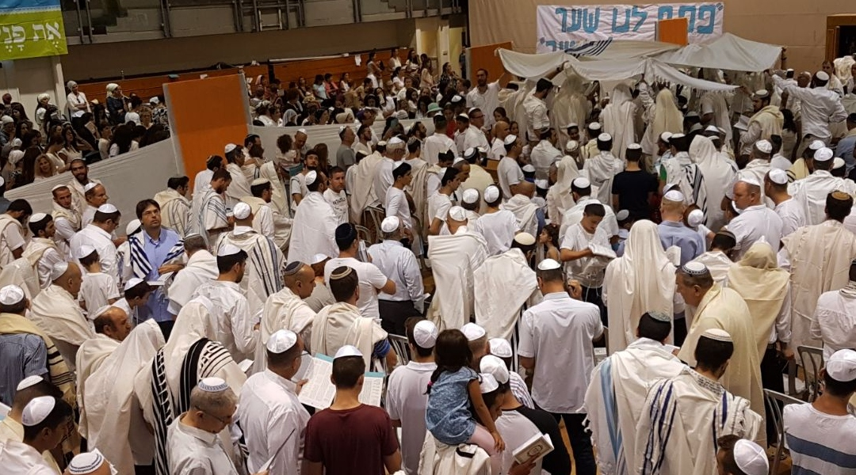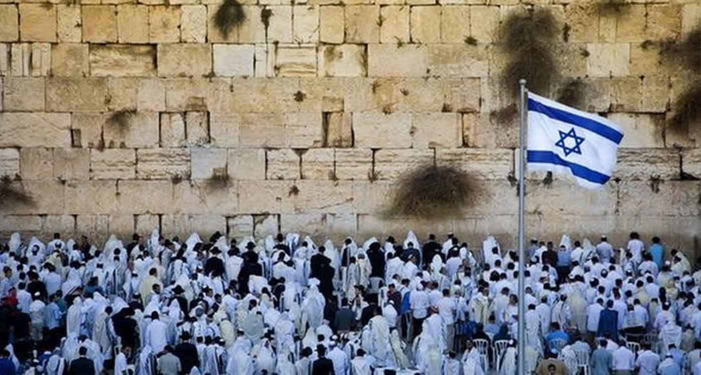Yom Kippur, most solemn of Jewish religious holidays, observed on the 10th day of the lunar month of Tishri (in the course of September and October), when Jews seek to expiate their sins and achieve reconciliation with God. Yom Kippur concludes the “10 days of repentance” that begin with Rosh Hashana (New Year’s Day) on the first day of Tishri. The Bible refers to Yom Kippur as Shabbat Shabbaton (“Sabbath of Solemn Rest,” or “Sabbath of Sabbaths”) because, even though the holy day may fall on a weekday, it is on Yom Kippur that solemnity and cessation of work are most complete. The purpose of Yom Kippur is to effect individual and collective purification by the practice of forgiveness of the sins of others and by sincere repentance for one’s own sins against God.What is Yom Kippur?-Yom Kippur is the most solemn of Jewish religious holidays, when Jews seek to expiate their sins and achieve reconciliation with God. It concludes the “10 days of repentance” that begin with Rosh Hashana on the first day of Tishri. It is on Yom Kippur that solemnity and cessation of work are most complete.What is the purpose of Yom Kippur?-The purpose of Yom Kippur is to effect individual and collective purification by the practice of forgiveness of the sins of others and by sincere repentance for one’s own sins against God.What time of year is Yom Kippur observed?-Yom Kippur is a Jewish religious holiday observed on the 10th day of the lunar month of Tishri (which occurs in September or October).